Step 1: Navigation in Oracle SQL Developer
- Open SQL Developer.
- Connect to your Oracle DB:
- Write Your SQL View:
- CREATE OR REPLACE VIEW vw_pre_match_summary AS
- SELECT
- customer_id,
- event_type,
- TO_CHAR(due_date, 'MM') AS month,
- TO_CHAR(due_date, 'YYYY') AS year,
- amount
- FROM pre_match;
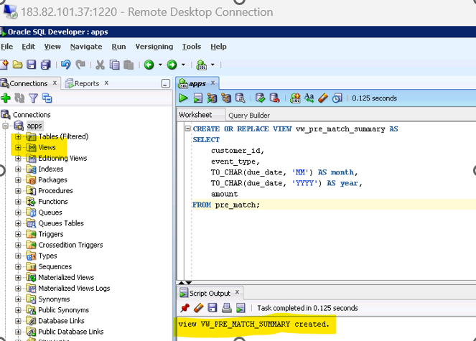
Views → Look for VW_PRE_MATCH_SUMMARY.
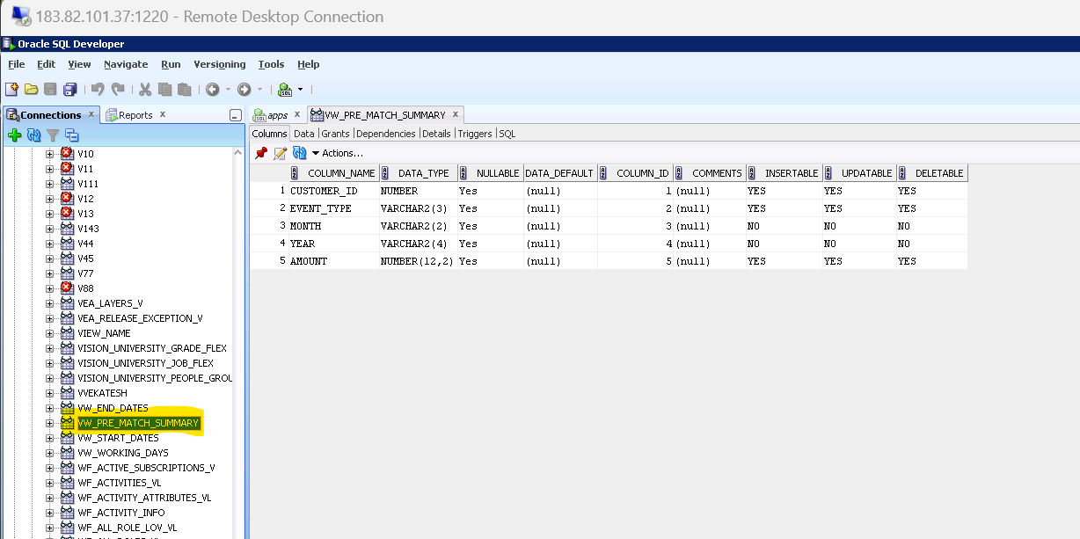
✅ After Creating the View
You can now use this view in Oracle Forms Builder as the data source for your blocks.
Step 2: Open Oracle Forms Builder
- Launch Oracle Forms Builder.
- Go to File → New → Form. (CNTRL + N)
✅ Step 2: Create a Data Block Using the View
- Go to: Tools → Data Block Wizard
- Choose: “Build a new data block manually” → Click Next
- Select: “Table or View” → Click Next
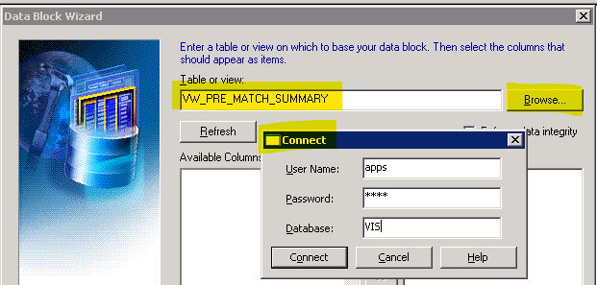
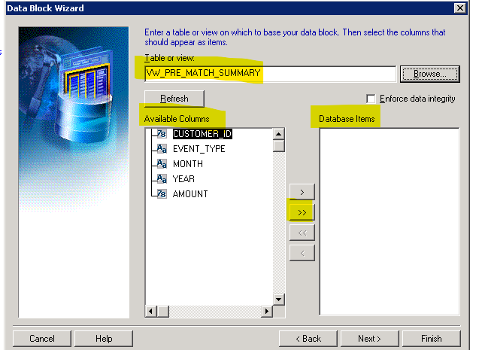
- Select Columns:
- CUSTOMER_ID, EVENT_TYPE, MONTH, YEAR, AMOUNT
- Click Next → Finish
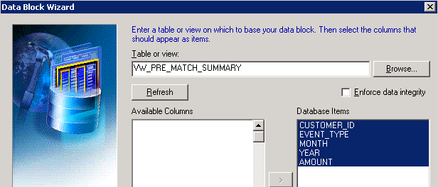
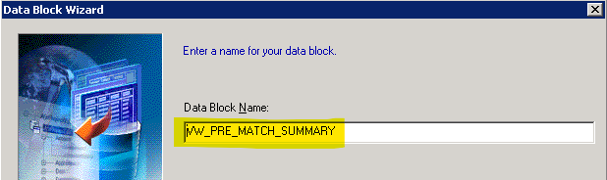
5. click FINISH.
6. Automatically Layout Wizard will open to create CANVAS.
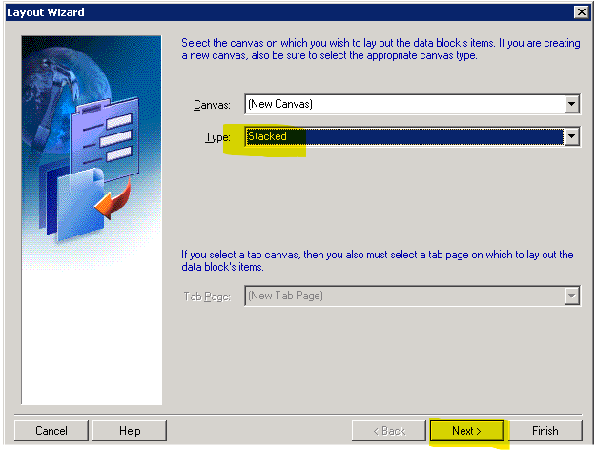
7. Choose Canvas Type: Use Stacked Canvas for grouped layout
8. Select Items to Display:
- Arrange fields as per your requirement:
  - Group by EVENT_TYPE → RSP, TSP, TOP
  - Display MONTH, YEAR, AMOUNT under each
9. Click: Next → Finish.
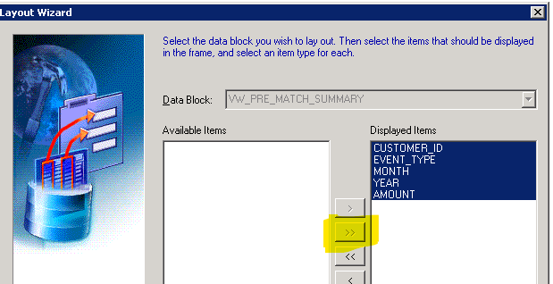
Next ->
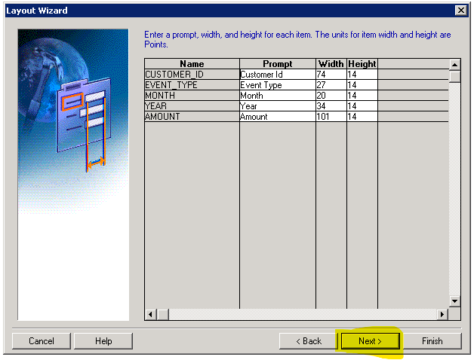
Layout style – Form -> Next -> FINISH.
LAYOUT CREATED
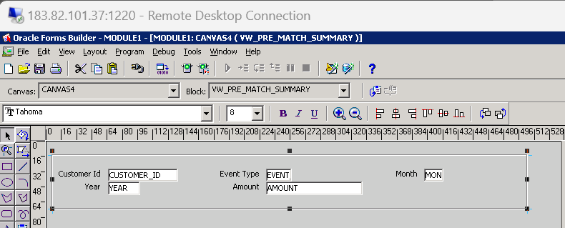
Save and Run the Form
- Save As: PRE_MATCH.fmb
- Run: Click the Run Form button (green triangle).
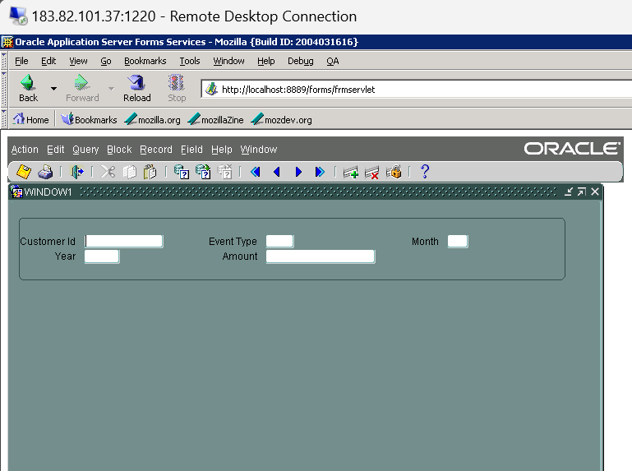
Done.
🔹 Step 1: Create the SQL View in Database
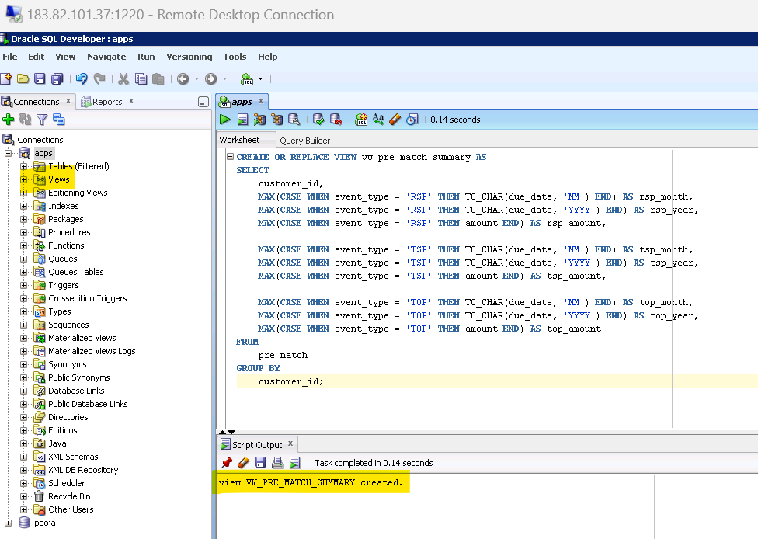
🔹 Step 2: Create a New Data Block in Oracle Forms
- Open Oracle Forms Builder.
- Go to Tools → Data Block Wizard.
- Choose Database Table or View.
- Enter the name: VW_PRE_MATCH_SUMMARY.
- Select all columns:
  - CUSTOMER_ID
  - RSP_MONTH, RSP_YEAR, RSP_AMOUNT
  - TSP_MONTH, TSP_YEAR, TSP_AMOUNT
  - TOP_MONTH, TOP_YEAR, TOP_AMOUNT
- Click Finish.
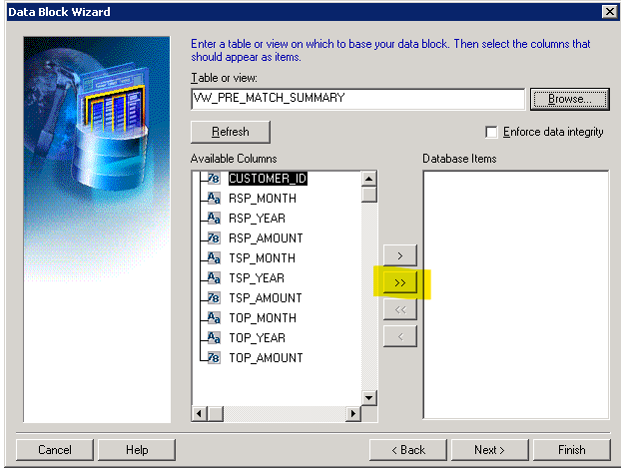
🔹 Step 3: Create the Layout
- After the block is created, the Layout Wizard will open.
- Take all columns into database.
- Next -> Choose Layout Style: Tabular Layout.

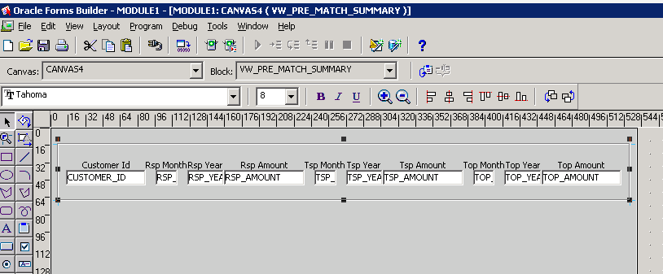

Created a frame and now shifting all RSP text and box to in frame.
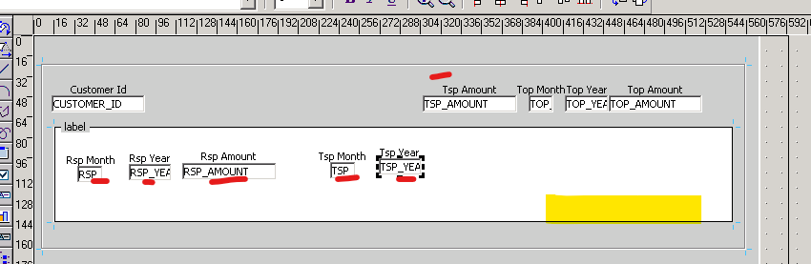
Done with Design, now put sample data and run.
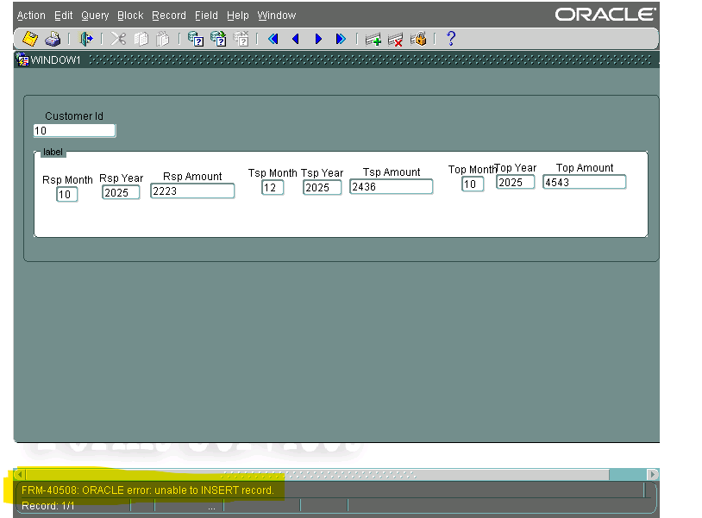
Error: FRM-40508: ORACLE error: unable to INSERT record
means Oracle Forms is trying to insert a record into the database, but it’s failing due to a backend issue.

17) You need to:
- Create a form with a button.
- When a date is passed, the form should:
  - Call a procedure.
  - Determine the previous working day (excluding weekends and holidays).
  - Display four columns of data for that previous working day.
- Use a view to fetch the data.
- Display the output in Oracle Forms.

🔹 Step 1: Create Supporting Tables:
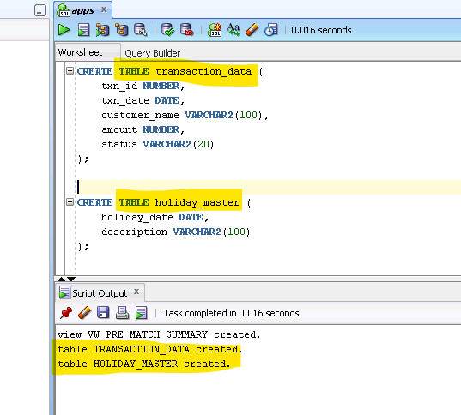
🔹 Step 2: Create a View
This view will filter data for a given date:
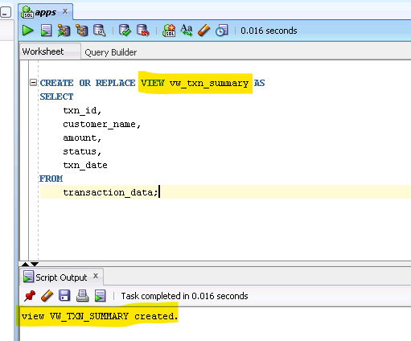

🔹 Step 3: Create the Procedure
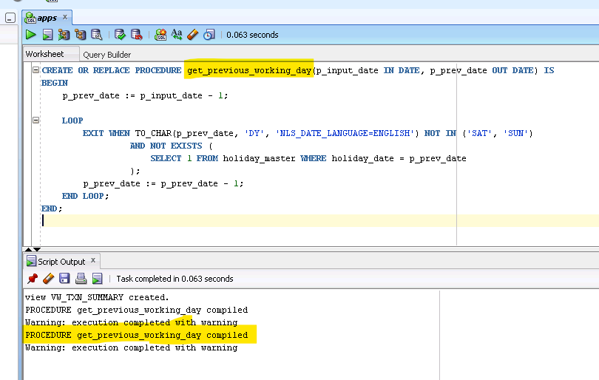
🔹 Step 4: Create the Form in Oracle Forms Builder
• Go to Tools → Data Block Wizard.
• Choose Database View → Select vw_txn_summary.
• Select fields: txn_id, customer_name, amount, status, txn_date.
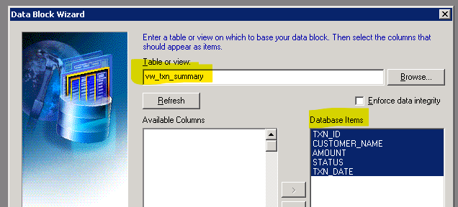
Create Layout with all columns.
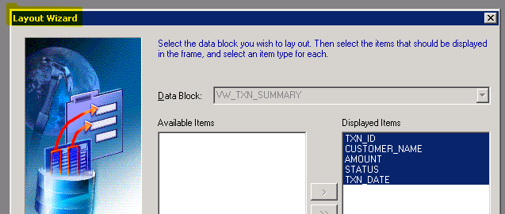
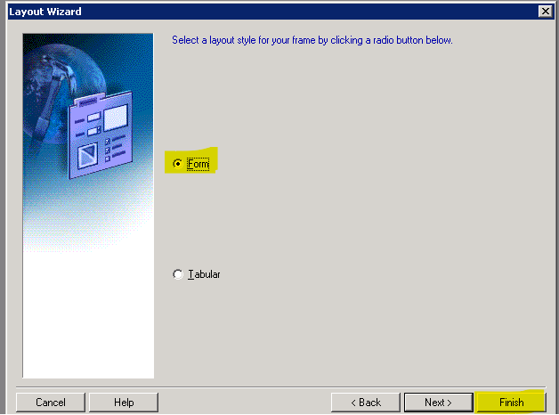Done.
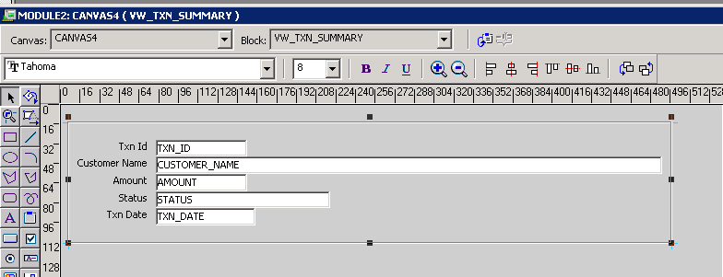
A. Add a Text Item for Date Input
Add a New Control Block (Optional):
- In Object Navigator → Right-click Blocks → Create
- Name it: CTRL_BLOCK
- Set Database Data Block → No
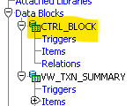
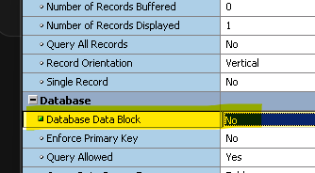
Add a Text Item:
- In Object Navigator → Expand CTRL_BLOCK → Right-click Items → Create
- Name it: INPUT_DATE
- Set properties:
  - Data Type: Date
  - Canvas: CANVAS1
  - Width: 20
  - Prompt: Enter Date. 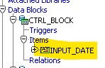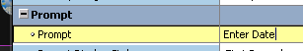
Place It on Canvas:
- In Layout Editor → Use Text Tool → Drag and drop the item
- Label it clearly: Enter Date
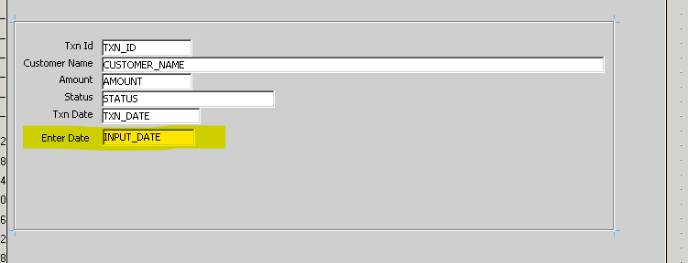
Placed.
B. Add a Push Button
- Create the Button Item:
  - In Object Navigator → Right-click CTRL_BLOCK → Items → Create
  - Name it: BTN_GET_DATA
  - Set properties:
    - Item Type: Push Button
    - Canvas: CANVAS1
    - Label: Get Previous Working Day Data.
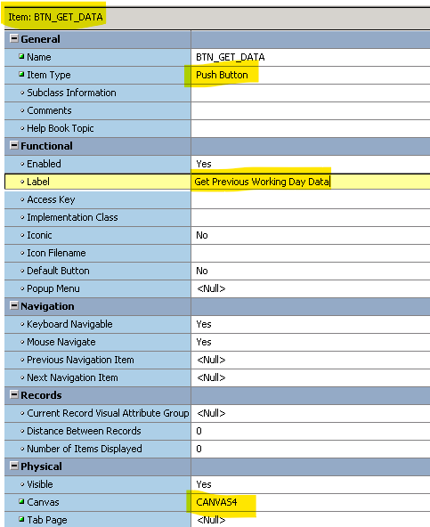
Place It on Canvas:
- In Layout Editor → Use Button Tool → Drag and drop the button next to the date field
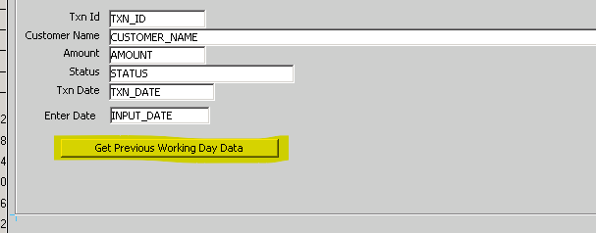Added.
🔸 C. Add Trigger to Button
- In Object Navigator → Expand BTN_GET_DATA → Right-click Triggers → Create
- Choose: WHEN-BUTTON-PRESSED
- Add this PL/SQL code:
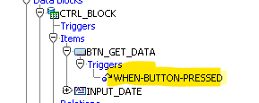
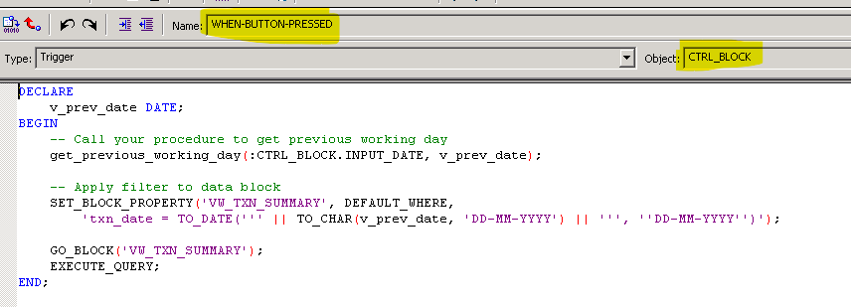
SUP_TIME_WEEKEND

